WEEK 4 INTERNSHIP REPORT
Implementation Strategy and Code Architecture Outline
Student Academic Risk Prediction

Virtual Machine Learning Implementation Intern

Project Detail | Information
Internship Week | Week 4
Project | Student Academic Risk Prediction
Programming Language | Python
Machine Learning Task | Three-class classification
Target Classes | Dropout, Enrolled, Graduate
Dataset | UCI – Predict Students' Dropout and Academic Success
Dataset Size | 4,424 records, 37 columns
Early-Prediction Features | 30 features after removing six second-semester fields
Main Libraries | pandas, NumPy, scikit-learn, matplotlib, seaborn

Prepared as part of the Week 4 implementation strategy assignment

1. Introduction
The Student Academic Risk Prediction project is being developed to predict a student's academic outcome as Dropout, Enrolled, or Graduate. The project uses Python and machine learning techniques on the UCI Predict Students' Dropout and Academic Success dataset. In the earlier weeks, the project was planned, different machine learning algorithms were studied, and an experimental evaluation process was carried out. Week 4 focuses on turning that work into a clear implementation structure. The main purpose is to explain how the code can be organized into separate modules, how data moves through the system, and how each stage can be tested and maintained.
A modular design is useful for this project because data preparation, model training, evaluation, and error analysis should not be mixed together in one large script. Separating these responsibilities makes the code easier to understand and also makes future changes safer. For example, another classifier can be added without rewriting the complete preprocessing process. The Week 4 design therefore follows a simple pipeline: data ingestion, inspection, exploration, preprocessing, feature selection, model training, cross-validation, evaluation, error analysis, and result storage.

2. Objectives of the Week 4 Implementation Strategy
- Define a practical architecture for implementing the Student Academic Risk Prediction system.
- Describe the flow of data from the input CSV file to the final evaluation results.
- Divide the project into small Python modules with clear responsibilities.
- Provide pseudocode for the core implementation stages.
- Explain maintainability, modularity, version control, and testing practices.
- Identify coding and integration risks and provide suitable mitigation strategies.

3. High-Level System Architecture
The proposed architecture keeps the project as a sequence of connected stages. The input is the student dataset stored as data.csv. The data is inspected and explored before preprocessing. For the early-prediction setting, the six second-semester features are removed so that information from a later semester is not used to make an earlier prediction. The remaining 30 features are processed using appropriate transformations. The processed data is then supplied to the selected machine learning models. Cross-validation and held-out test evaluation are used to compare model performance, followed by error analysis and result storage.
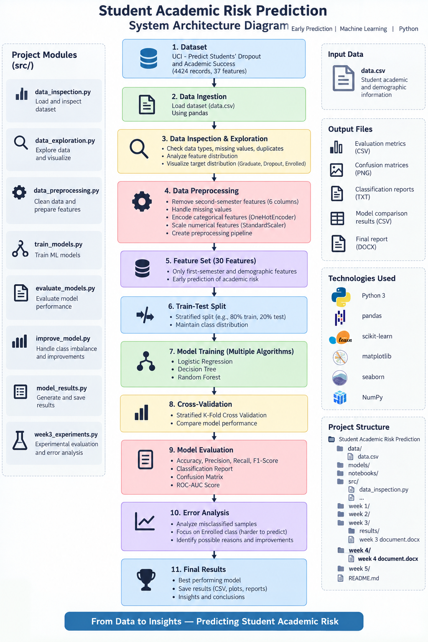
Figure 1. High-level system architecture for Student Academic Risk Prediction.

4. Step-by-Step Implementation Strategy
1. Data ingestion: Read data/data.csv using pandas with the required semicolon separator and verify that the file is available.
2. Initial inspection: Check the number of rows and columns, column names, data types, missing values, duplicates, and target distribution.
3. Feature preparation: Remove the six second-semester fields from the modeling feature set to maintain the early-prediction objective.
4. Train-test split: Separate the target from the input features and create a stratified 80:20 train-test split using a fixed random state.
5. Preprocessing: Apply one-hot encoding to categorical features and standard scaling to numerical features through a scikit-learn ColumnTransformer.
6. Model definition: Prepare Logistic Regression, Decision Tree, and Random Forest classifiers using consistent preprocessing.
7. Cross-validation: Use Stratified K-Fold cross-validation on the training data to estimate model performance across multiple folds.
8. Model training: Fit each complete pipeline on the training data.
9. Evaluation: Generate predictions on the held-out test set and calculate accuracy, macro precision, macro recall, macro F1, weighted F1, ROC-AUC, classification reports, and confusion matrices.
10. Error analysis: Inspect incorrect predictions, with particular attention to the Enrolled class, which was harder to classify in the Week 3 experiment.
11. Result storage: Save metrics, reports, confusion matrices, and plots in the week 3/results area or an appropriate future results directory.

5. Data Flow
START
|
v
Load data.csv
|
v
Inspect data and target
|
v
Remove six second-semester features
|
v
Separate X (features) and y (Target)
|
v
Stratified 80:20 train-test split
|
v
Build preprocessing pipeline
|-------------------------------|
| |
v v
Categorical features Numerical features
One-Hot Encoding Standard Scaling
| |
|---------------+---------------|
v
Combined features
|
v
Train ML model pipelines
/ | \
v v v
LR DT RF
\ | /
v
Stratified K-Fold CV
|
v
Held-out test evaluation
|
v
Metrics + reports + matrices
|
v
Error analysis
|
v
Save final results
|
v
END

6. Modular Breakdown of the Python Codebase
The current project already follows a modular approach. Each Python file has a particular purpose. The following breakdown explains how the existing files fit into the Week 4 architecture.
Module / File | Main Responsibility | Expected Input / Output
data_inspection.py | Loads the dataset and performs basic inspection. | Input: data.csv; Output: shape, columns, basic checks.
data_exploration.py | Examines data types, duplicates, target counts and percentages, and numerical summaries. | Input: data.csv; Output: exploration information.
data_preprocessing.py | Prepares features and builds the preprocessing approach. | Input: raw features; Output: train/test data and preprocessing pipeline.
train_models.py | Trains the selected baseline classifiers. | Input: prepared data/pipeline; Output: trained model results.
evaluate_models.py | Evaluates model predictions using classification metrics and confusion matrices. | Input: trained models/test data; Output: evaluation metrics.
improve_model.py | Tests an improved configuration, including class balancing. | Input: training data/model pipeline; Output: comparison results.
model_results.py | Summarizes and organizes model performance results. | Input: evaluation results; Output: summary.
week3_experiments.py | Runs the leakage-safe experimental design, cross-validation, held-out evaluation, ROC-AUC and error analysis. | Input: data.csv; Output: Week 3 result files and plots.

7. Pseudocode for Core Functions and Modules

7.1 Data Ingestion and Inspection
FUNCTION load_and_inspect_data(file_path):
CHECK that file_path exists
READ CSV file using pandas
DISPLAY dataset shape
DISPLAY column names
CHECK data types
CHECK missing values
CHECK duplicate rows
DISPLAY target class counts
RETURN dataset

7.2 Feature Preparation
FUNCTION prepare_features(data):
COPY the dataset
DEFINE the six second-semester columns
REMOVE those columns from the feature set
SET Target as y
SET remaining columns as X
IDENTIFY categorical and numerical columns
RETURN X, y, categorical_columns, numerical_columns

7.3 Train-Test Split and Preprocessing
FUNCTION build_preprocessing(X, y):
SPLIT X and y into training and testing sets
TEST SIZE = 20 percent
STRATIFY using y
RANDOM STATE = 42
CREATE numerical transformer using StandardScaler
CREATE categorical transformer using OneHotEncoder
COMBINE them with ColumnTransformer
RETURN X_train, X_test, y_train, y_test, preprocessor

7.4 Model Training
FUNCTION train_models(preprocessor, X_train, y_train):
DEFINE Logistic Regression
DEFINE Decision Tree
DEFINE Random Forest
FOR each model:
CREATE a Pipeline containing:
preprocessing step
classifier
FIT pipeline using X_train and y_train
STORE fitted pipeline
RETURN fitted models

7.5 Cross-Validation
FUNCTION run_cross_validation(models, X_train, y_train):
CREATE Stratified K-Fold with 5 folds
USE accuracy, macro precision, macro recall,
macro F1, and weighted F1 as scoring measures
FOR each model:
RUN cross-validation on training data
STORE mean and fold-level scores
RETURN comparison information

7.6 Model Evaluation
FUNCTION evaluate_model(model, X_test, y_test):
GENERATE predictions for X_test
CALCULATE accuracy
CALCULATE macro precision
CALCULATE macro recall
CALCULATE macro F1
CALCULATE weighted F1
GENERATE classification report
GENERATE confusion matrix
IF probability scores are available:
CALCULATE one-vs-rest macro ROC-AUC
SAVE metrics and reports
RETURN evaluation results

7.7 Error Analysis
FUNCTION analyze_errors(model, X_test, y_test):
GENERATE predictions
COMPARE predictions with actual labels
SELECT incorrect predictions
COUNT each actual-to-predicted class combination
IDENTIFY classes with frequent errors
EXAMINE the Enrolled class separately
SAVE error counts and observations
RETURN error analysis summary

8. Code Architecture and Design Principles
- Single responsibility: each module should perform one main type of work rather than mixing inspection, training, and reporting.
- Separation of data and code: raw data stays under data/, source files stay under src/, and generated outputs are stored separately.
- Reusable preprocessing: the same preprocessing pipeline should be applied consistently during training, cross-validation, and testing.
- Clear interfaces: functions should accept clear inputs and return predictable outputs.
- Configuration over repetition: shared settings such as random_state and test size should be kept consistent.
- Readable naming: file, function, and variable names should describe their purpose.
- Avoid unnecessary duplication: common processing should be placed in reusable functions instead of copied into multiple scripts.
- Reproducibility: fixed random states and recorded experiment settings help reproduce results.

9. Python Code Maintainability and Best Practices

9.1 Coding Standards
The project should use consistent indentation, descriptive names, short functions, and comments where the reasoning is not obvious. Python files should be kept focused on a specific responsibility. Long scripts can be divided into functions so that individual parts can be tested without running the complete pipeline.

9.2 Dependency and Environment Management
A virtual environment is used for the project so that Python packages are isolated from the system installation. The environment should not be uploaded to GitHub. Dependencies should be recorded separately so that the project can be recreated on another computer.

9.3 Version Control
GitHub is used to maintain the project history. Week 1, Week 2, and Week 3 work have already been uploaded to the repository. Changes should be committed with meaningful messages. Large generated files, virtual environments, cache folders, and temporary files should be excluded through .gitignore where appropriate.

9.4 Testing Strategy
- Test dataset loading before running model training.
- Check that expected columns exist before preprocessing.
- Verify that missing values and duplicates are handled or reported.
- Check the number of rows after train-test splitting.
- Verify that the target classes are represented in both training and test sets.
- Test preprocessing and model pipelines with a small sample before a full experiment.
- Check that saved result files are created in the expected directory.
- Compare repeated runs with the same random state to confirm reproducibility.

10. Integration Strategy
The modules are integrated through a common dataset and consistent feature-processing logic. A typical run starts with data inspection and exploration, followed by feature preparation and model training. The evaluation stage receives the trained pipeline and test data rather than independently transforming the test set. This is important because the transformations learned from training data should be reused during prediction. The use of scikit-learn Pipeline and ColumnTransformer helps keep preprocessing and classification connected and reduces the chance of applying different transformations at different stages.

11. Implementation Risk Assessment and Mitigation
Risk | Possible Impact | Mitigation Strategy
Dependency/version mismatch | A script may behave differently or fail on another computer. | Use a virtual environment and document package versions.
Incorrect file paths | Scripts may fail when moved or run from another directory. | Use organized project folders and predictable relative paths.
Data leakage | The model may use information that would not be available at prediction time. | Remove the six second-semester features from the early-prediction feature set.
Class imbalance | The model may favor common classes and perform poorly on Enrolled students. | Use macro metrics, confusion matrices, error analysis, and compare class-balanced training.
Preprocessing inconsistency | Training and testing data may be transformed differently. | Use a shared scikit-learn preprocessing pipeline.
Code duplication | Changes may need to be made in multiple places and introduce bugs. | Keep reusable logic in functions and focused modules.
Random variation | Results may change between runs. | Use fixed random states and stratified splitting/cross-validation.
Integration errors | A model may receive the wrong feature format. | Keep preprocessing and model in one Pipeline and validate feature columns before execution.
Large generated outputs | The repository may become unnecessarily large or difficult to manage. | Keep only useful reports/results under version control and ignore temporary files.

12. Scalability and Future Extension
The architecture is designed so that the project can be extended without replacing the entire codebase. Additional machine learning algorithms can be added to the model-training stage and evaluated with the same pipeline. Hyperparameter tuning can be introduced later. A separate prediction module could also be created to load a saved model and predict the academic-risk class for a new student record. If a user interface is required in a later stage, it can call the prediction module without changing the core preprocessing and training logic. This modular structure is also suitable for continuing the project in the next semester.

13. Implementation Checklist
- Confirm data.csv is available in the expected data directory.
- Run data inspection and verify the dataset structure.
- Run data exploration and verify target distribution.
- Prepare the early-prediction feature set by removing second-semester features.
- Create a stratified train-test split.
- Build and validate the preprocessing pipeline.
- Train the selected classifiers.
- Run stratified 5-fold cross-validation.
- Evaluate models on the held-out test set.
- Generate confusion matrices and classification reports.
- Perform error analysis.
- Save experiment outputs in an organized results directory.
- Commit meaningful project changes to GitHub.

14. Alignment with Week 3 Experimental Work
The Week 4 architecture is directly based on the experimental process completed in Week 3. The Week 3 experiment used 30 features after removing the six second-semester features. It used an 80:20 stratified train-test split and five-fold stratified cross-validation. Logistic Regression, Decision Tree, and Random Forest were evaluated using accuracy, macro precision, macro recall, macro F1, weighted F1, confusion matrices, and one-vs-rest macro ROC-AUC. Error analysis was also performed, including a closer look at errors involving the Enrolled class. Week 4 converts this experimental workflow into a maintainable code architecture so that the same process can be extended and maintained in future work.

15. Conclusion
The Week 4 implementation strategy provides a practical structure for the Student Academic Risk Prediction project. Instead of treating the ML workflow as one large program, the system is divided into clear stages for inspection, exploration, preprocessing, training, evaluation, and error analysis. The proposed architecture also keeps data, source code, and generated results organized separately. Using scikit-learn pipelines, stratified validation, reproducible settings, GitHub version control, and basic testing practices makes the project easier to maintain. The design can also support future improvements such as hyperparameter tuning, additional models, a saved prediction service, or a user interface. Overall, the architecture provides a clear implementation plan that is consistent with the experimental work completed in the previous week.

16. References
- UCI Machine Learning Repository. Predict Students' Dropout and Academic Success dataset.
- Python Software Foundation. Python documentation.
- pandas documentation. Data analysis and manipulation in Python.
- scikit-learn documentation. Machine learning tools and pipeline utilities.
- Matplotlib documentation. Visualization library for Python.
- Seaborn documentation. Statistical data visualization library.

